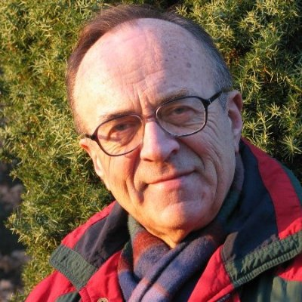
ANDRZEJ STRUPCZEWSKI
Nuclear Physicist, Poland

Andrezej Strupczewski, Chairman of Nuclear Safety Commission, National Centre for Nuclear Research. Vice-president of the Association of Ecologists for Nuclear Energy SEREN. He is a member of the Board of Advisors for Environmentalists for Nuclear – USA. He has 55 years of experience in nuclear reactors technology and safety, of which 50 years with the National Centre for Nuclear Research, Poland, and 20 years as an expert of the European Commission, the IAEA and Enconet Consulting, Austria. The leading designer of shielding of MARIA reactor, main author of MARIA safety analysis report, head of MARIA reactor technological start-up. Recent major tasks: evaluation of four advanced reactor designs for UK HSE, development of methodology for fission product releases under accident conditions, evaluation of EU TACIS and INSC nuclear safety programmes for EU, comparisons of costs impacts on energy system of nuclear power, coal, wind and solar energy sources. He has 5 books, 250 publications, 40 international training courses.

