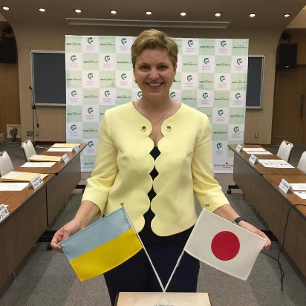

Yuliya Lyamzina, PhD, MBA
Ms. Lyamzina is currently working as Assistant Professor at the Radiation Medical Science Centre of the Fukushima Medical University (FMU).
She holds two Master degrees in Political Science and International Relations and Ph.D. in Public Health, Epidemiology and Hygiene from the Masaryk University in Brno, Czech Republic.
Prior to her joining FMU, Ms. Lyamzina has worked for the United Nations Office of Drugs and Crime Prevention, United Nations High Commissioner Office for Refugees and lately for the International Atomic Energy Agency (IAEA).
Currently Ms. Lyamzina is working on the project related to the social and psychological problems of Fukushima people which focuses among other things, on nuclear waste management, risk perceptions factors and how to integrate obtained results into effective risk messages and ultimately into successful risk communication in “existing exposure” situations.
She is fluent in Russian, English, Spanish, Czech, German and currently learning Japanese.

