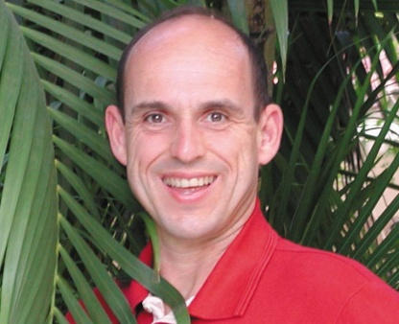
BRUNO COMBY
Nuclear Engineer, France
Bruno Comby is Founder – President of Association of Environmentalists for Nuclear Energy, EFN-International, in French Association des Ecologistes Pour le Nucléaire, AEPN. Author of 10 books on nuclear energy, the environment, and healthy living, some books have been translated into 15 languages. World researcher on natural and man-made low dose radiation. Member, Board of Directors and Board of Advisor for Environmentalists for Nuclear – USA and Environmentalists for Nuclear - Canada. Advisor to Environmentalists for Nuclear – UK and Poland. Designer - builder of net positive electrical energy state of the art eco-home in Houilles, France. Advocate for the world to have nuclear powered electrical transportation system as much as possible: trains, subways, cars, as in France. Lead advocate for nuclear energy to provide for the welfare of humanity and help preserve of clean, healthy environment. His organizations have over 10,000 affiliates in 60 countries.

