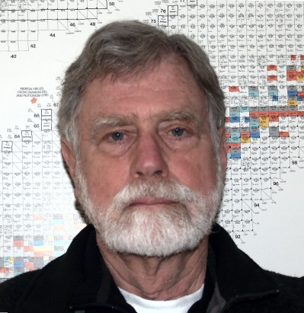
Steve Baker Ph.D.
Dr. Baker holds degrees in mathematics and nuclear engineering from Oregon State University. He served as an officer on U.S. Navy nuclear submarines. He managed the groundwater investigation for the Basalt Waste Isolation Project to determine the suitability of the basalt layers under the Hanford site for high-level nuclear waste disposal.
He has been a consultant for 30 years serving clients in areas of risk assessment, investigation of nuclear contaminated sites, and groundwater transport. He was on the team that developed a recirculating well system for removing volatile organics from groundwater.

